**Project Report Template**

**Introduction**

* 1. **Overview**

A resume summary or career proﬁle is a brief statement at the top of your resume. If you are a career changer or have many years of experience, craft a powerful summary to highlight your accomplishments and skills. Show the employer, at a glance, why you're qualiﬁed for the job.

**2.2 Purpose**

Resumes tell the employer about your experiences, skills and work history. Use your resume to highlight items that indicate you are a good worker, are qualified for the position and bring desirable skills to the job.

**Problem definition & Design thinking**

**2.1 Empathy map**

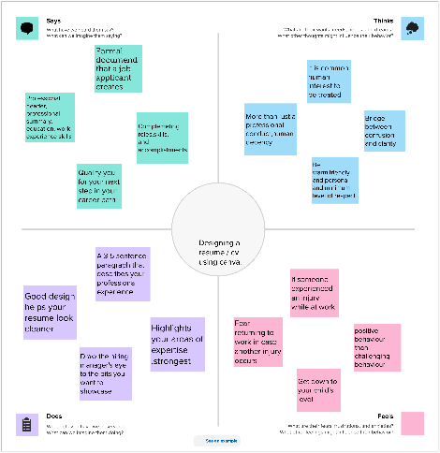

**2.2 Brainstroming**

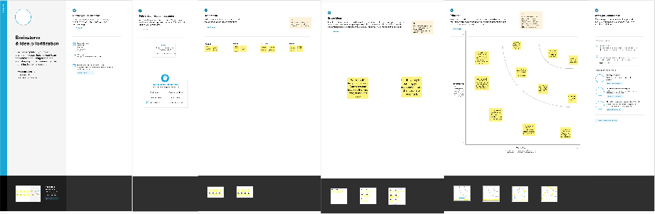

**RESULT**

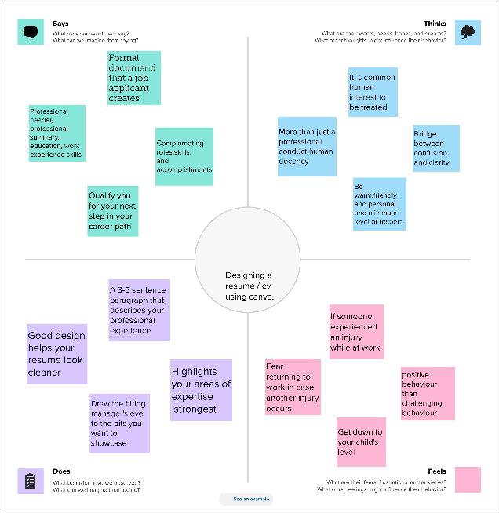

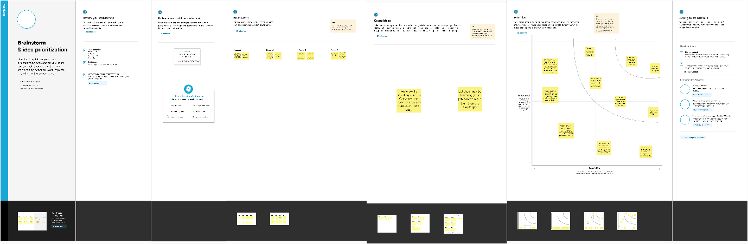

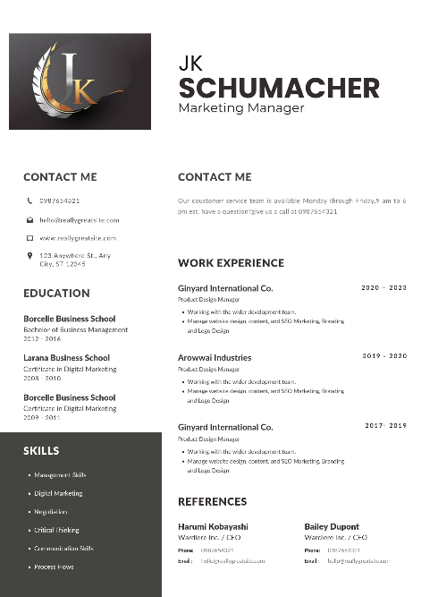

**ADVANTAGES AND DISADVANTAGES**

Advantages

* Boost your self-confidence.
* Prove your knowledge.
* Show teamwork skills.
* Make your application stand out and leave a lasting impression.
* Make your interview process more effective and efficient.
* Improve your employability.
* Personal Details.
* Skills and Experience.

Disadavantages

* It is harder to compare the skills and experience of different candidates.
* You may not get a true sense of whether a candidate is suitable for the job and skills required to perform their role.
* Gaps in education or work can be hidden more easily by the job applicant.

**APPLICATION**

* Find the right template. Choose from hundreds of professionally-designed resume templates. ...
* Personalize your resume. After picking a template, use Canva's drag and drop design tools to tweak your resume. ...
* Get creative with more features. ...
* Order your prints.

**COUNCLUSION**

If you summarise your professional credentials, such as qualifications and work experience, at the start of your resume and end with your hobbies and interests, it might provide a comprehensive overview of you as a candidate for the vacant role and company culture.

**FUTURE SCOPE**

A while it does offer a wide range of templates and design elements, it lacks the depth and versatility of professional design software like Adobe Creative Cloud. This can be a major drawback for designers who need more control and flexibility in their work.